**PCB DESIGN**

**Making the Iduino File**

By correlating what is visible of the pin numbers on the Iduino, with the known pin layout of the Arduino Due, the physical pin map for the Iduino Due could be determined. The pin rows that match are shown on the figures.

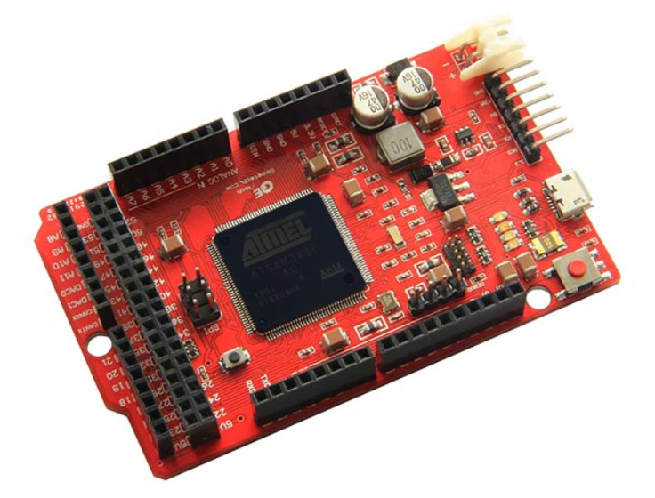

**C**

**H**

**G**

**F**

**D&E**

**B**

**A**

**H**

**G**

**D&E**

**F**

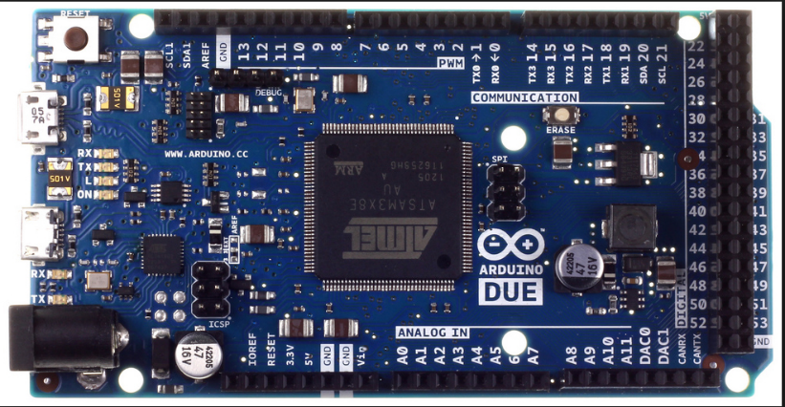

**C**

**B**

**A**

The pins within these headers are in the same order (by observation).

The next step was estimating the real distance between each headers to find the physical dimensions of the board, which appears to be quite different between the Iduino Due Pro and Arduino Due.

Visually, the pins were placed in approximate positions. The space between G and H appears to be half a pin header (as per Arduino standard) however the rest were nothing more than educated guesses.

The layout is shown below with each cross representing a hole in the PCB (into which we will stick pin headers).

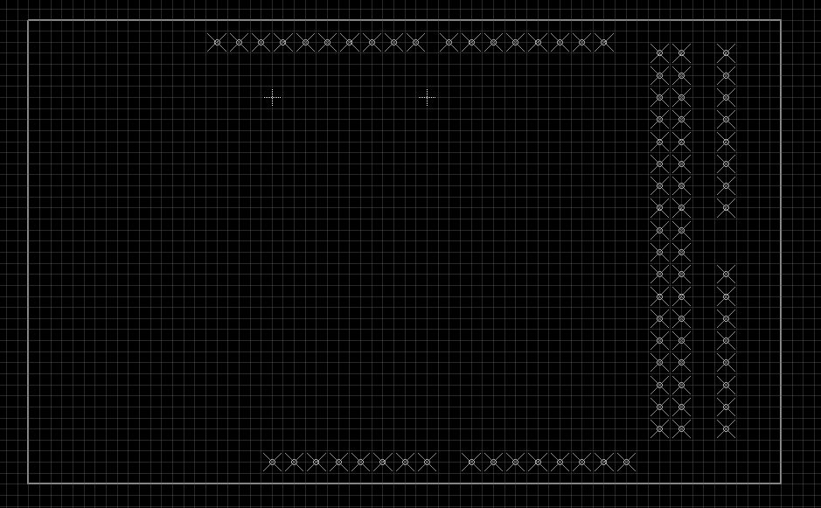

Since the pin headers are spaced 2.54mm apart, there is not enough room for another row of pins along the width and the width is given at 53.3mm we can confirm that the current design is reasonable.

The rectangular box around the pins measures 86.36mm by 53.34 mm which is close to the 86.3x53.3 mm given as the dimensions